Siddh Deshmane  Senior Software Engineer - Exp 5.2 years  📞 (+91)8275798466 📍Pune  📧 deshmane.siddh@gmail.com  EXPERIENCE  ProductDossier Solutions, Pune — Senior Software Engineer  April 2015 - PRESENT  - TouchBase solution consists of certain main modules to provide the functionalities of Project Lifecycle Management. These modules are tightly integrated to provide end to end fully integrated solution.  - The modular approach provides the flexibility to deploy in an incremental fashion based on need and investment.  - TouchBase has an open, 100% Java architecture and makes extensive use of XML to share and manage information.  - In recent years we also migrated our front end in Angular technology which has reintroduced in terms of its UI.  - Easy access to its data repository makes it the information source of choice for other applications and functions that would normally replicate data.  - Using XML technology, new applications easily leverage this information bus that is an integral part of TouchBase. It removes data duplication, maintains data accuracy, and reduces complexity and cutting costs.  EDUCATION  Post Graduate Diploma in Advance Computing (C-DAC), Pune  📍C-DAC Pune  🗓FEB 2014 - July 2014  Bachelor of Engineering in Information Technology  📍University of Pune | 67%  🗓July 2010 - May 2013  HSC  📍HSC Board, Maharashtra | 73.74%  🗓July 2008 - April 2009  SSC  📍SSC Board, Maharashtra | 78.30%  🗓June 2006 - April 2007 | 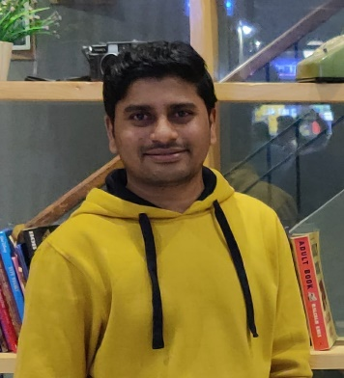  SUMMARY  I am a technology enthusiast, problem solver and believe in learning new skills with a sense for aesthetics and interaction.  SKILLS  Java, Spring, Spring boot, JavaScript, Angular, SQL Server, git  LANGUAGES  English  Proficient  Hindi  Proficient  Marathi  Proficient  AWARDS  1. Best Fresher (Year 2015-16)  2. Consistent Performance and Contribution to TouchBase Product Development in 2016  PASSIONS    Technology    Traveling    Sports  FIND ME ONLINE    @deshmaneSiddh

